Sign Language Regonization using CNN Algorithm with Meachine Learning Techniques

M Akilan^{a)}, M F Akila Lourdes ^{b)},
Panimalar Engineering College, Chennai,India

^{a)}Corresponding author:akilanak2205@gmail.com, ^{b)}akilalourdes@gmail.com,

Abstract. Deaf and hard-of-hearing people use sign language, a visual language, to communicate with one other and with people who do not know sign language. However, due to a lack of accessibility and communication hurdles, there is an increasing demand for technologies to help sign language users and the hearing community communicate. A system called sign language recognition with text and audio tries to fill this gap by automatically decoding sign language motions into spoken or written words. The procedure entails a number of processes, including image preprocessing, feature extraction, gesture detection, and translation into text or speech. The intricacy and variety of sign language motions are one of the major obstacles to text and audio-based sign language recognition. As a result, creating precise and trustworthy identification systems involves both a vast and varied collection of sign language motions as well as powerful machine learning methods like Convolutional Neural Networks (CNNs) and Long Short-Term Memory (LSTM) networks. The ability to recognise sign language using text and audio has the potential to significantly increase accessibility and communication for the deaf and hard-of-hearing community, allowing them to interact more freely with the hearing community and take part more completely in society. Along with other industries, it has uses in entertainment, healthcare, and education. Technology has the ability to revolutionise interpersonal communication and close the gap between groups speaking various languages as it develops and gets better.

Keywords— Face recognition, Convolutional Neural Network, and Hand motions are all used in sign language understanding.

Introduction

In the modern world, those who are mentally impaired frequently lack the means of conversing normally with others. As just a small percentage of their gestures are recognised by most people, it has been noticed that they occasionally find it extremely challenging to engage with regular people. Due to their inability to communicate verbally like hearing people, deaf persons and those with hearing impairment must frequently rely on visual means of communication. In the community of the deaf and dumb, sign language is used most frequently. It contains syntax and vocabulary much like any other language, but instead of using words to communicate, it uses pictures.When stupid or deaf persons use these grammars in sign language to communicate with others, problems develop. This is due to the common ignorance of these grammars among everyday people. Therefore, it has been observed that a dumb person's communication is only restricted to members of his or her family or the deaf community. Individuals who are deaf or hard of hearing use sign language, a visual language, to communicate with one other and with those who do not understand sign language. The demand for technology to help sign language users and the hearing population communicate is growing, though, as a result of accessibility issues and linguistic obstacles. This requirement is being met by technology that automatically recognises sign language motions and translates them into spoken or written language. This technology is known as sign language recognition with text and audio. Typically, sign language gesture recognition with text and audio uses computer vision and machine learning algorithms to extract features from video data, identify sign language motions, and generate related text or speech. There are a number of processes in the procedure, including image preprocessing, feature extraction, gesture recognition, and translation into text or speech. For the deaf and hard-of-hearing community, sign language recognition with text and audio has the potential to significantly increase accessibility and communication, allowing them to interact with the hearing community more readily and participate fully in society. It also has uses in the realms of entertainment, healthcare, and education, among others. As technology develops and advances, it has the ability to change interpersonal communication and close the gap between groups speaking various languages.

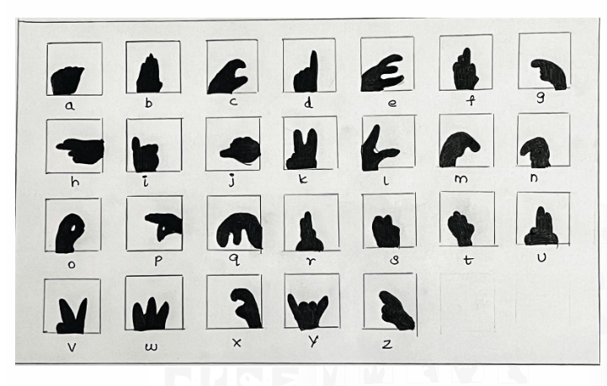
Figure 1: INDIAN SIGN FOR ALPHABETS

Existing System

Hidden Markov Models(HMMs) are utilised extensively in the detection of sign languages. A single HMM is used to model every symbol. Each video frame's feature vectors must be taken out before being input into the HMM for both training and recognition. A HMM-based system that uses one colour lens to monitor bare hands over a period of time and determines American Sign Language using HMMs with a lexicon of 40 words uses cotton gloves with multiple colour markings on the signers' hands and reinforces of their hands in order to muster both path and hand shape characteristics from video. However, cotton gloves are not always required or the only means to record hand motions, despite the advantages they can provide for sign language recognition systems.

Drawbacks:

- The main challenge is modelling the probability of giving a tag to a word, which can be highly challenging if "words" are complicated.
- Multiple overlapping features and long-term interdependence cannot be represented in a realistic manner.
- There are many parameters that need to be assessed. Consequently, it requires a sizable data collection for training. In order to get better results, extensive training is necessary.

LITERATURE SURVEY

[1] Title: Sign Language Recognition Using Gesture Recognition and Natural
Language Processing
Author: Aditi Patil, Anagha Kulkarni, Harshada Yesane, Minal Sadani
Year: 2021

DESCRIPTION:
For Indian Sign Language to be recognised as a minority language, the numerous deaf populations in India continue to fight. The translation of Indian Sign Language to the matching English language passage calls for a mechanism. For this, the visual and nonvisual input from Sign Language signs must be processed, translated into English words, and then these words must be put together into a sentence (or sentences) that are grammatically correct and understandable. The researchers have focused on processing data that can be sensor-based, image-based, with movies in their entirety, or sampling videos at set intervals of time to determine the trajectories of motions.
A hardware system for hand movement recognition, pictures, or video format are just a few examples of the inputs that could take any shape. The current literature that identifies areas of interest in non-visual inputs, picture frames, and video frames to ascertain the attributes for a certain hand gesture is the main emphasis of this paper. The review of the literature also considers the methodologies used by scholars studying other sign languages, like American Sign Language, Taiwanese Sign Language, etc.; this will serve to put Indian Sign Language in perspective.
The Viterbi algorithm, tokenization, part-of-speech tagging, parsing, and other Natural Language Processing techniques have all been used in past studies to translate a movie into the English language. This work also reviews those techniques.

[2] Title: Indian Sign Language Gesture Recognition using Image Processing and Deep Learning
Author: Neel Kamal Bhagat, Y. Vishnusai, G. N. Rathna
Year: 2020

DESCRIPTION:
Those who are unable to speak do so by making hand gestures.
The majority of individuals, however, are not familiar with the meanings behind these gestures. We suggest an ongoing recognition of hand gestures method relying on information obtained by the Microsoft Kinect RGB-D camera in an effort to overcome this gap. We employed computer vision methods like 3D building and affine transformation because there isn't a one to one mapping between the pixels of the depth and the RGB camera. The hand motions were separated from the surrounding audio after reaching a 1:1 mapping. The training of 36 static gestures for ISL characters and numbers was carried out utilising CNN. Using 45,000 RGB photos and 45,000 depth images for training, the model has an accuracy of 98.81%. Ten ISL dynamic word gestures were further trained using convolutional LSTMs, and 1080 videos were used to achieve an accuracy of 99.08%. There is still need for more research on how sentences are formed through gestures because the model demonstrated accurate real-time performance on ISL static gesture prediction. When the ISL model weights were transferred to ASL and the accuracy was given as 97.71%, the model also demonstrated competitive adaptability to ASL gestures.

[3] Title : Dynamic Sign Language Recognition Based on Convolutional Neural Networks and Texture Maps
Author: Edwin Escobedo, Lourdes Ramirez, Guillermo Camara
Year: 2019

DESCRIPTION:
Due to the intricacy of learning or constructing descriptors to capture its major aspects (location, movement, and hand configuration), SLR is an extremely difficult undertaking. In this research, we suggest a reliable deep learning-based method for sign language recognition. To characterise the hand's position and movement, our method represents multimodal information (RGB-D) through texture maps. In addition, we provide a simple technique for identifying a frame that best captures the contour of the hand. Then, in order to develop strong features capable of identifying a dynamic sign, we feed this data into two three-stream and two two-stream CNN models, respectively. We conduct our tests using 2 signed language datasets, and the contrast with innovative SLR approaches demonstrates the advantages of our methodology, which ideally mixes texture and signal.

[4] Title : The Application of Convolution Neural Networks in Sign Language Recognition
Author: Yiwen Zhao, Lidan Wang
Year: 2019

DESCRIPTION:
CNN offers a key approach for recognising sign language. The impact of various factors on training MNIST is first thoroughly addressed in order to effectively train the dataset. Then, using the same methodology, perform an analogue analysis, choosing the best parameters from a series of pre-training on the ASL dataset. A sign language recognizer filter with an accuracy rate of around 90% is created after formal training.

[5] Title: Sign Language Recognition Using Modified Convolutional Neural Network Model
Author: Suharjito, Herman Gunawan, NaradaThiracitta , AriadiNugroho
Year: 2019

DESCRIPTION:
Similar to Action Recognition, sign language is an intriguing subject.
Particularly in light of Deep Learning's impressive advancement. We're interested in video-based sign language recognition because we want to be able to identify signs not just by their shape but also by the activity they are made of. The issue lies in how diverse and intricate sign language is. The machine finds it more challenging to precisely recognise every word because of the variety in sign language. The recognition of sign language has been the subject of extensive investigation for many years. To determine which strategy is the best, numerous approaches had been tried. We are attempting to incorporate one of the best models in Action Recognition, i3d inception, because Sign Language Recognition and that technology are related. This model is also a brand-new, highly accurate Action Recognition model. In order to determine whether it is feasible to incorporate Action Recognition behaviour into Sign Language Recognition. The objective of this research is to use the transfer learning method and the i3d inception model to the recognition of sign language.

[6] Title: Hand Gesture Recognition with Generalized Hough Transform and DC-CNN Using Realsense
Author: Bo Liao, Jing Li, Zhaojie Ju, Gaoxiang Ouyang
Year: 2018

DESCRIPTION:
In the connection between humans and computers, hand gesture recognition is crucial. Depth cameras have made it possible to mix colour images with depth images to produce greater data for hand gesture identification. Based on the information obtained by the Intel RealSense Front-Facing Camera SR300, we suggest a hand gesture detection system in this study. The recognition system maps depth photos to colour images based on generalised, taking into account the fact that the pixels in the depth images that RealSense has acquired are not identical to those in colour images.
Using the depth information in colour photographs, Hough transform is used to separate the hand from a complicated background. The system then uses a unique double-channel convolutional neural network with two input channels—color images and depth images—to recognise various hand motions. Additionally, we created a library of hand motions with 24 distinct types, each one representing a letter of the English alphabet. With 84,000 RGB photographs and 84,000 depth images, it has a total of 168,000 pictures. The success of the suggested approach is demonstrated by experimental findings on our newly compiled hand gesture database, and the recognition accuracy is 99.4%.

[7] Title: Real-time sign language fingerspelling recognition using convolutional neural networks from depth map Author: Byeongkeun Kang, SubarnaTripathi, Truong Q. Nguyen
Year: 2018

DESCRIPTION:
For natural and practical communication between the hearing majority and the deaf community, sign language understanding is crucial. Utilising convolutional neural networks (CNNs) built from depth maps, we take the incredibly effective first stage of automatic fingerspelling recognition system. Comparing this work to earlier literature, we take into consideration a comparatively higher number of classifications. We use a subset of depth data gathered from various participants to train CNNs for the categorization of 31 alphabets and numerals. While utilising various learning setups, such as hyper-parameter selection with and without validation, we achieve 99.99% accuracy for observed signers and 83.58% to 85.49% accuracy for new signers. As more data from various subjects is used during training, accuracy increases, as the result demonstrates. An individual image forecast takes 3 ms to process. We believe the system to be the most accurate and quick available. On our repository, you can find the trained model and dataset.

[8] Title: Interpretation of sign language into English using NLP techniques.
Author: SS Wazalwar, U Shrawankar
Year: 2017

DESCRIPTION:
A means of communication for the dumb and deaf is sign language. It is possible to recognise signs using a variety of systems that produce words for each sign they identify. The suggested method focuses on translating sign language into appropriate English sentences. Furthermore to signature acknowledgment, different NLP methods are applied. A clip of gestures is used as the input, and then the video is framed and segmented. For tracking, the P2DHMM method and the CamShift algorithm are also used.

[9] Title: Sign language recognition using image based hand gesture recognition techniques
Author: Ashish S. Nikam, Aarti G. Ambekar
Year: 2017

DESCRIPTION:
Among the strategies utilised in the use of sign language regarding non-verbal interaction is the hand gesture. Deaf and dumb persons who have difficulty speaking or hearing most frequently use it to interact with other people. Many makers throughout the world have created several sign language infrastructure, however ultimately users are unable to use them since they're neither adaptable nor affordable.
In order to enable deaf and dumb individuals communicate with normal people and each other more efficiently, this study introduces software that shows a system prototype that can automatically recognise sign language. The expanding topics of inquiry include pattern recognition and gesture recognition. Hand gestures play a big part in our daily lives and are a crucial aspect of nonverbal communication. Through the assistance of a hand gesture's detection system as a whole we may communicate with computers in a unique, comfortable, and user-friendly method that is more accustomed to humans. The programme strives to offer an ongoing system for understanding hand gestures on a foundation of recognition of particular shape-based characteristics like the initial phase, revolve of worship the central point, fingertips situation, and common sense in roles of brought up or rolled fingers of on hand. This is done by maintaining an eye on the way comparable the physical form of a person's hand is to the form of four fingers along with a thumb.

[10] Title: Framing sentences from sign language symbols using NLP
Author: U Shrawankar, S Dixit
Year: 2016

DESCRIPTION:
Deaf or dumb persons are unable to understand normal people in conversation.
People who are deaf or stupid have grammatical errors in their sentences.
Prior to now, image processing techniques have only been used to transform sign language to text in word format. A useful technology for translating in human language is NLP. This effort is in charge of creating understandable phrases that a typical person can read out of sign language symbols.

Proposed Methodology

Convolutional Neural Network (CNN)

Convolutional neural networks, usually referred to as CNN algorithms / ConvNets are are a class of feedforward artificial neural networks whose connectivity topology is motivated by the arrangement of the animal visual cortex. cells in small groupssome portions of the visual field have a sensitivity in the visual brain.A synthetic neural network is an illustration of CNN, which analyzes data using supervised learning and the perceptron learning rule. CNN is used in conjunction with other cognitive processes to process the image [11].These networks are similar to other artificial neural networks but differ from natural neural networks in that they feature input, output, and a number of hidden layers, some of which employ convolutional algorithms model to transport results to subsequent networks Layers.Several processes in the human visual brain are imitated by this[12] The deep learning algorithm is best shown by CNN.
The levels in which input is provided to our model are called the "input layer," the "hidden layer," and the "output layer" [11].The entire number of characteristics in our data is the same number of neurons as there are in these layers.

The covert layer is fed information from the input layer through the hidden layer.[13] Various hidden layers with varying data sizes may exist depending on our model[14].There are normally more neurons than features in each buried layer, which may contain a variety of them.
To create a nonlinear network, the activation function and learnable biases are added after the matrix multiplication of the outcome of the layer preceding it by the weights of the subsequent layer.

Layer of output
The output from these hidden layers is then sent into a logistic function, such as sigmoidal or so fmax layer, which turns the conclusion of each group into probability score for every group.
AsConvNets require far less preprocessings than other classification methods, in comparison. ConvNets can learn these filters and their attributes, in contrast to naive approaches where filters are manually created[15].The Visual Cortex's organizational principles had an impact on the design of a ConvNet, which shares similarities with the human brain's connectivity network.
Individual neurons only respond to stimuli in these restricted visual fields, termed by the Open-minded Area[17]. These are combined to fill the whole field of vision.
A ConvNet is capable of recording the relationships between time and space as a picture by employing the appropriate filters. The design offers superior fits to the data set of images because there are less parameters to take into account and the weights can be reused[16]. On a nutshell, the neural network might be trained to better understand the degree of complexity in the image. CNN are a deep learning approach that were created with the help of the cortex of the eye, which serves as the building blocks of human vision.

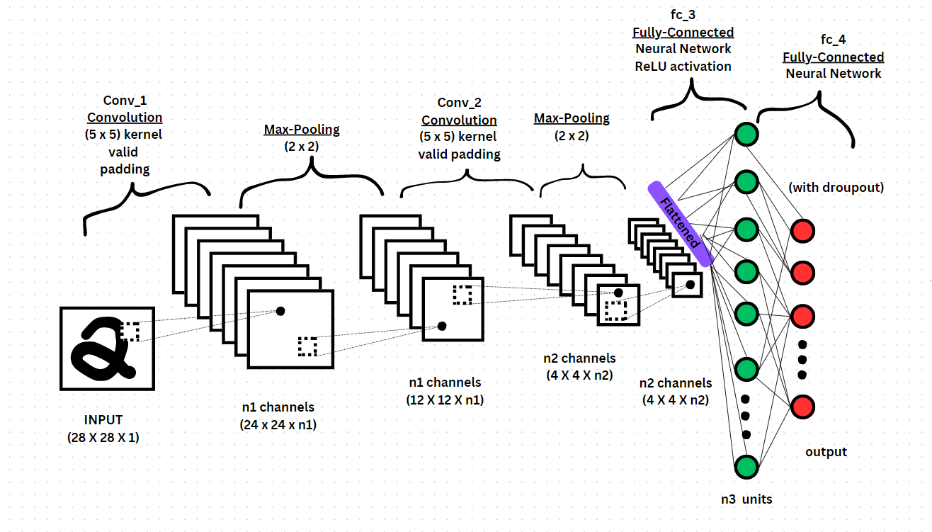

Figure 2: Architecture for convolution neural network

Convolution (wT X) and pooling (max()) are the two main operations carried out by CNN, and these blocks are linked in a very sophisticated way to resemble the human brain.
The neural network, or neural net[15], is built up of layers, therefore as the variety of levels grows, so does the complexity of the network and, as a result, the correctness for the whole thing.
The CNN's complicated architecture is composed of up of three operational building parts that are connected to one another[20].
The following layers make up the convolutional neuronal network:
- Convolutional Layer
- Max Pooling Layer
- Fully-Connected Layer.

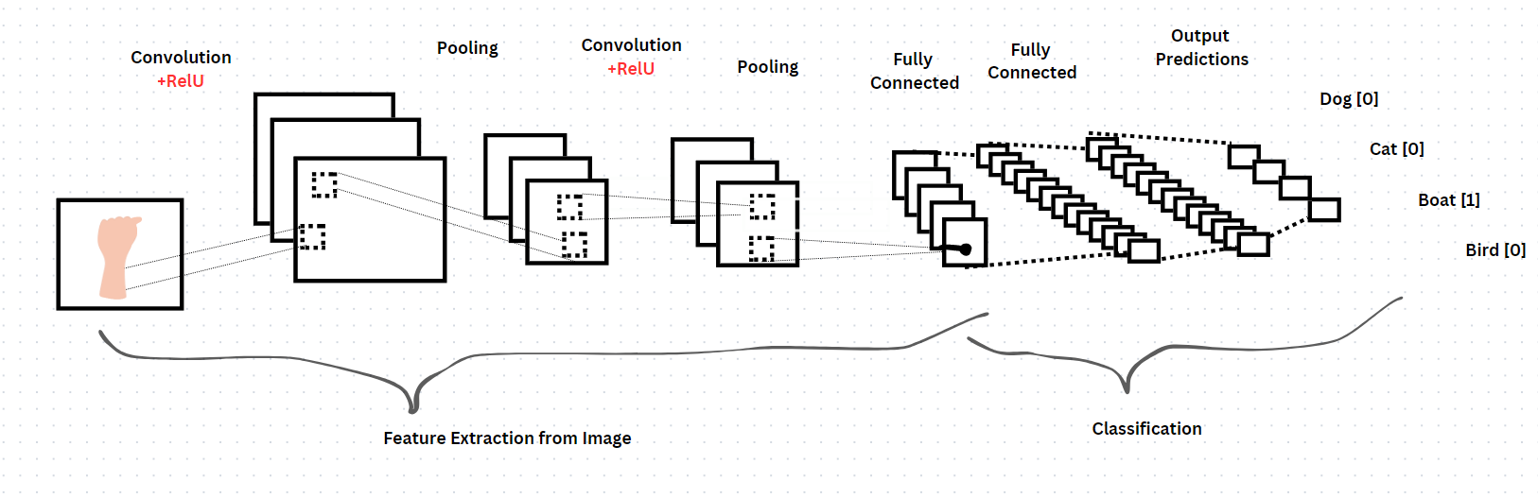
Figure 3: Extraction of CNN

Several phases and procedures are commonly used in the process for sign language recognition. The process is described generally as follows:
1. Data collection: Compile a thorough database of sign language films or pictures that includes a variety of different movements and variants. To guarantee robustness and generalisation[17], this dataset should comprise a varied range of signers, signing techniques, and ambient factors.
2. Pre processing: To improve quality and get rid of any noise or unnecessary information, clean up and pre process the data that has been collected. Images may need to be resized, lighting conditions may need to be normalised, and background clutter may need to be reduced.
3. Feature Extraction: Take the data from the preprocessed sign language and extract useful features. Features can indicate different hand gestures, hand motions[19], facial emotions, and other pertinent sign language gestures. Methods based on image processing, computer vision, or deep learning can all be used as feature extraction approaches.
4. Modulation: Utilise the retrieved characteristics to describe the sign language gestures using a suitable modulation approach (such as image-based, skeleton-based, or trajectory-based)[24]. The goal of this stage is to convert the visual data into an appropriate mathematical or computational representation.
5. Training and Model Development: Train a model for sign language recognition using the modulated data. Diverse machine learning or deep learning methods, such HMM, RNN, CNN[21], or Transformers, may be used in this. Based on the available training data, the model learns to identify and categorise the sign language gestures.
6. Evaluation and Performance Analysis: Analyze the trained model's performance using suitable evaluation metrics, such as precision, recall, accuracy, or F1 score. Evaluate the generalization, robustness, and correctness of it. proficiency with test or validation datasets[22]. To find patterns of error in recognition and opportunities for development, perform a detailed analysis of errors.
7. Improvement and Modification: Adapt hyperparameters iteratively, change the architecture, or use sophisticated training methods like transfer learning or data augmentation to improve the model[17]. Apply the learnings from the evaluation and error analysis to the model's fine-tuning.
8. Implementation and Real-world Testing: Implement the trained and improved model in real-world situations, such as communication apps, educational settings, or assistive technology[21]. Observe how well it performs and how usable it is in real-world situations. Get user input. Then, depending on those experiences and requirements, make the required adjustments.
9. Continuous Improvement: Continue to enhance the model iteratively and continuously by taking into account user input, gathering more data, and doing so as necessary[23]. This guarantees that the system is up to date, precise, and sensitive to the changing needs of sign language users.

Data collection, pre-processing, feature extraction, model training, evaluation, and refinement are all steps in the methodology for sign language recognition, which is a continuous process. To create efficient and useful software, it is necessary to combine domain knowledge, machine learning methods, and user-centered design concepts.

Image Dataset:
Green,Red and Blue color planes have been separated from an GRB image. In several of these color spaces, images can be discovered.

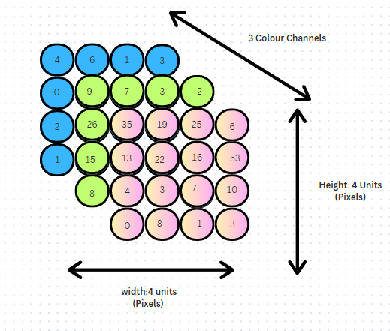

Figure 4: convolution kernel layer

Convolution Operation's objective is to identify an input image's high-level properties, like edges. One convolutional layer is not a prerequisite for ConvNets. The initial ConvLayer typically is responsible for capturing basic attributes like boundaries, shade, fade orientation, etc.

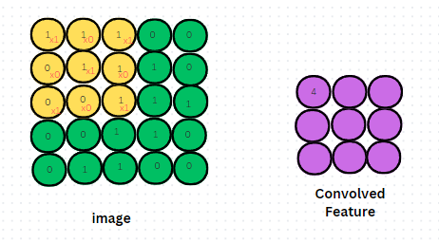
Figure 5: The produces two distinct types of results
one where the dimensionality of the features that have been involved is reduced in comparison to the inputs, and the other where it is either raised or remains constant. valid applications, PaddingsinsThis is done by using the former's cases, or by using the exact same cushioning in the latte's cases.

Advantages:

- Without the need for human supervision, it automatically recognises the crucial elements.
- They excel at managing image classification.
- All image locations utilise the same knowledge.
- Jarvis algorithm and template matching algorithm are used by the system to identify integers and alphabets respectively.
- Using Principal Component Analysis (PCA) and several distance classifiers, a system for identifying continuous gestures was created.

ARCHITECTURAL DIAGRAM

A camera is used in this system's architecture to record different hand motions. After that, multiple algorithms are used to process the image.

The image is first subjected to preprocessing. Utilising an edge detection technique, edges are then determined. After that, the sign is recognised and the text is displayed using a template-matching algorithm. One can quickly determine the meaning of a specific sign because the output is text.
The difficulty of communicating with the deaf is also reduced as a result. OpenCV-Python has been used to implement the system. Many libraries are used by the system.

1. Input: This part represents the information that the sign language recognition system receives, such as video streams or image sequences obtained from cameras or other sensors.
2. Preprocessing: The preprocessing component handles the essential tasks on the incoming data to improve its quality and get it ready for future processing. This could entail operations like noise reduction, image stabilisation, backdrop removal, or hand tracking.
3. Feature Extraction: This part of the system pulls out pertinent features from the preprocessed data. The hand shape, movement, and facial expressions that are important in sign language gestures can be captured by these elements. Contour analysis, motion tracking, and deep learning-based feature extraction are examples of common feature extraction approaches.
4. Gesture Recognition: The gesture recognition component examines the collected features and evaluates them in comparison to a predetermined set of sign language gestures. To translate the input movements into specific signs or phrases, it uses machine learning or pattern recognition algorithms. Using labelled sign language data to train a model and increase recognition accuracy may be part of this component.
5. Sign-to-Text Conversion: This component converts a recognised sign language gesture to its appropriate textual representation after the gesture has been identified. In order to do this, it may be necessary to keep a dictionary or database of textual equivalents for sign language motions.
6. Output: The system's ultimate product as represented by the output component. One way to do this is to display on a screen the text equivalents of the recognised sign language gestures. In order to do this, it may be necessary to show the recognised sign language motions as text on a screen or to translate them into spoken English utilising
speech synthesis from text.

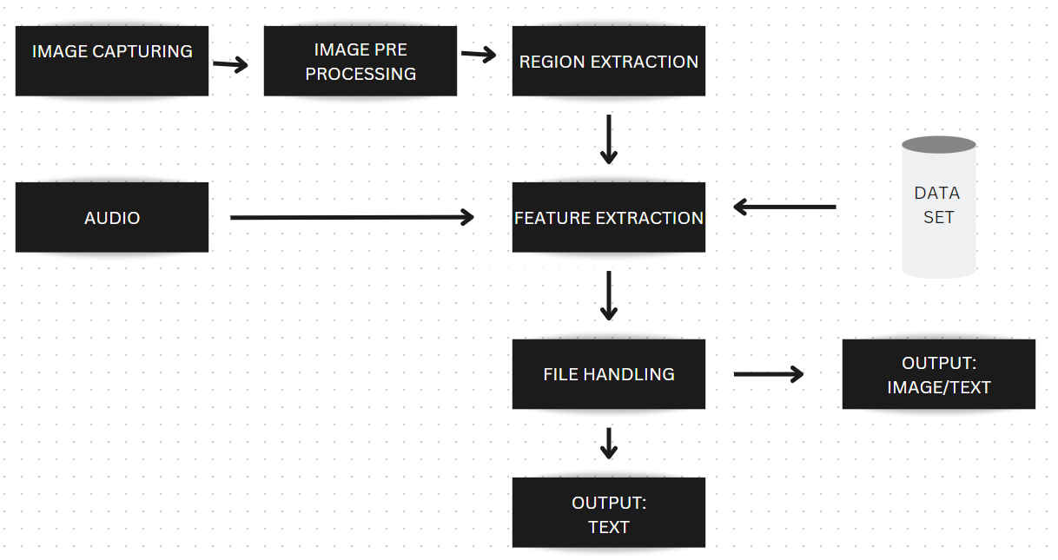
Figure 6: Architecture Diagram

RESULTS AND DISCUSSIONS

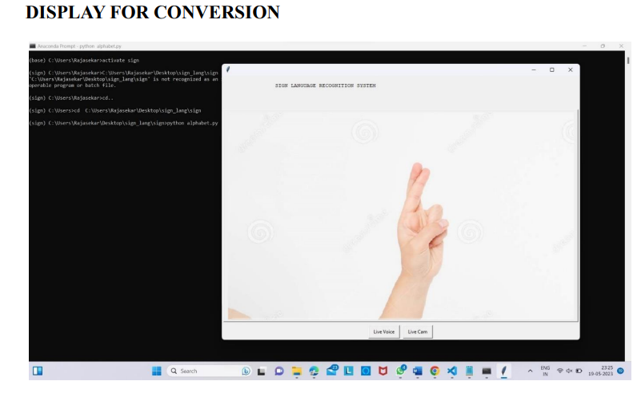
Figure 7: Display for Conversion

The above figure displays the conversion of signs for letter r
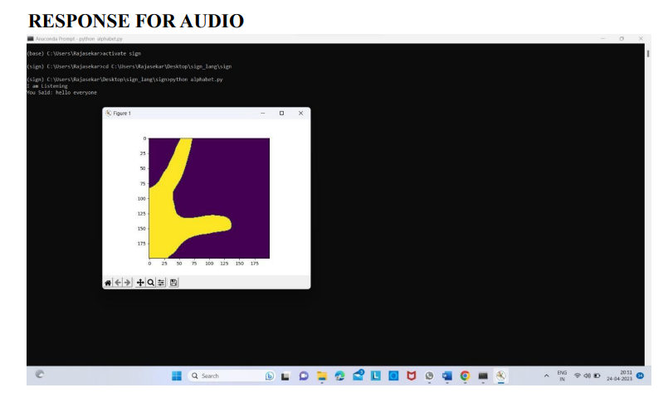
Figure 8: Response for audio

The above figure represents the response for an audio file for a letter L

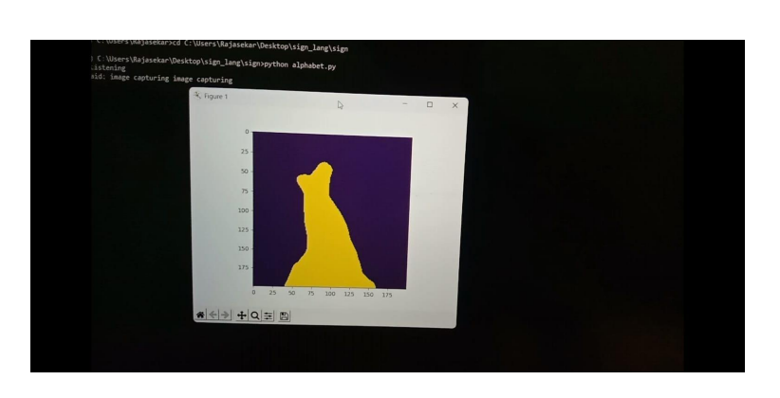
Figure 9: Response for audio
The above figure represents the response for an audio file for a letter r

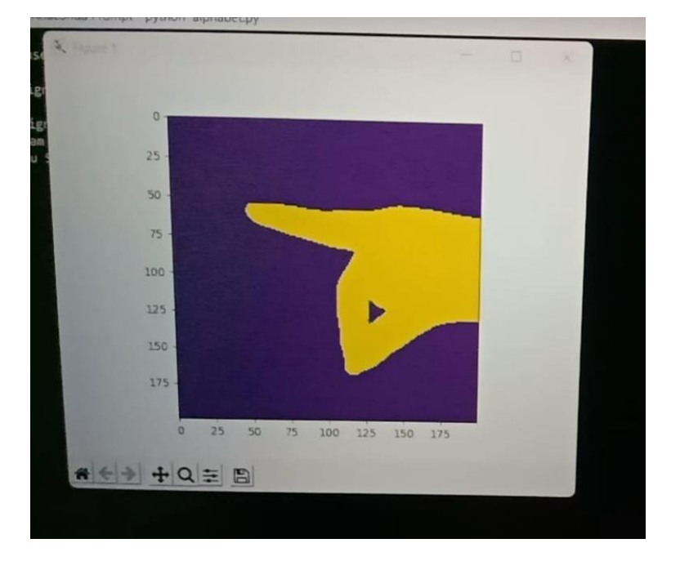
Figure 10: Response for audio

The above figure represents the response for an audio file for a letter p

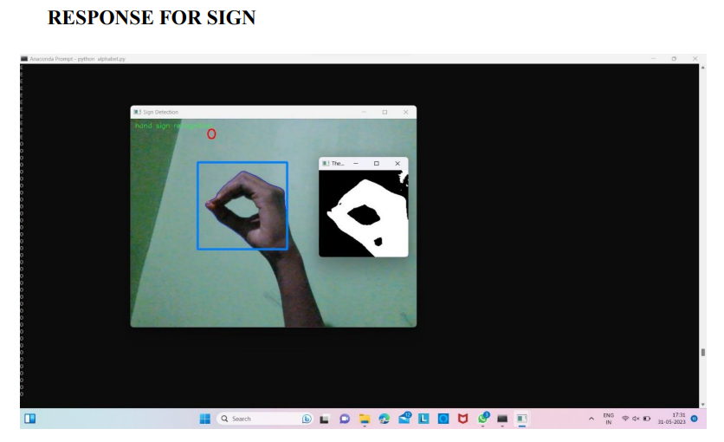
Figure 11: Response for sign
The above figure represents the response for sign for a letter o

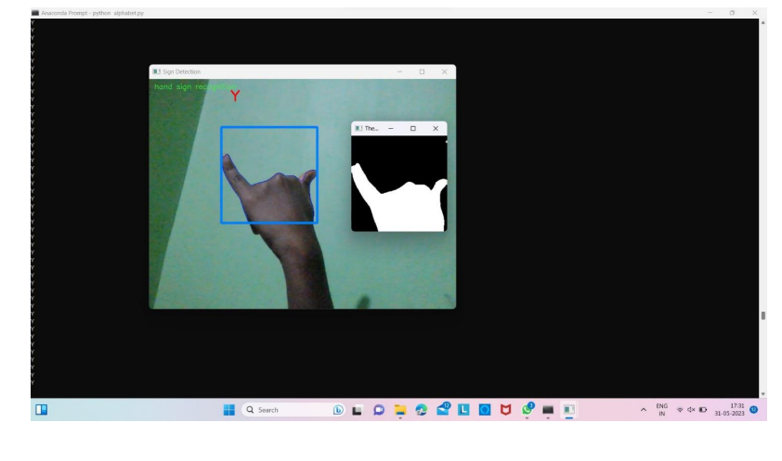
Figure 12: Response for sign
The above figure represents the response for sign for a letter y

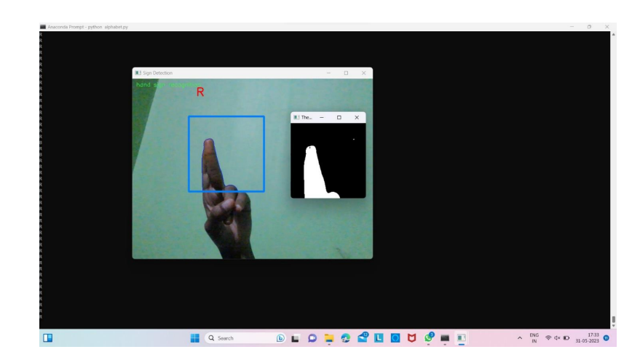
Figure 13: Response for sign
The above figure represents the response for sign for a letter r

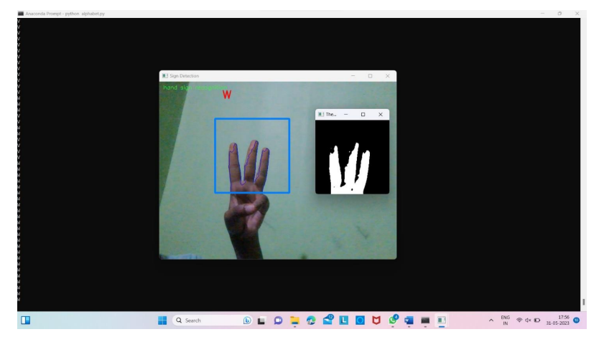Figure 14: Response for sign
The above figure represents the response for sign for a letter w

CONCLUSION

For individuals who use the language of signs as their main method of interaction, recognition of sign language software offers enormous potential for reducing communication gaps and enhancing accessibility. In order to accurately understand and translate sign language movements into text or spoken language[25], sign language recognition systems have made significant progress by utilising innovative visual analysis and artificial intelligence strategies.
To increase inclusivity, enable effective communication, and enable people with hearing impairments to fully participate in various aspects of life, including education, employment, and social interactions, sign language recognition systems have been developed[25]. The deaf and hard-of-hearing community's ability to communicate and interact with the general public more easily may be revolutionised by these solutions. The evaluation of sign language recognition systems is a vital stage in their development since it ensures their precision, resilience, and efficacy in real-world situations. Researchers and developers can pinpoint the benefits, drawbacks, and potential areas for development through rigorous evaluation procedures[21], thereby enhancing the functionality and usefulness of these systems.
Beyond particular applications, sign language recognition has a broad use. It has the potential to be incorporated into a variety of fields, including education, communication devices, assistive technology, and virtual reality settings[11]. We can make democracy a better place for those with hearing impairment by integrating sign language recognition into commonplace technologies.
In conclusion, sign language identification technology offers the deaf and hard-of-hearing community a promising means of improving communication and removing barriers. Continued study, creation[15], and cooperation in this area will promote inclusive technologies and enable people with hearing loss to fully engage in a diverse and interconnected world.

REFERENCES

[1] “Sign Language Recognition Using Gesture Recognition and Natural Language Processing” Aditi Patil, Anagha Kulkarni, Harshada Yesane, Minal Sadani - 2021 .
[2] “Indian Sign Language Gesture Recognition using Image Processing and Deep Learning” Neel Kamal Bhagat; Y. Vishnusai, G. N. Rathna - 2020.
[3] “Dynamic Sign Language Recognition Based on Convolutional Neural Networks and Texture Maps” Edwin Escobedo, Lourdes Ramirez, Guillermo Camara - 2019
[4] “The Application of Convolution Neural Networks in Sign Language Recognition” Yiwen Zhao, Lidan Wang – 2019.
[5] “Sign Language Recognition Using Modified Convolutional Neural Network Model” Suharjito, Herman Gunawan, NaradaThiracitta, AriadiNugroho - 2019
[6] “Hand Gesture Recognition with Generalized Hough Transform and DCCNN Using Realsense” Bo Liao, Jing Li, Zhaojie Ju; Gaoxiang Ouyang – 2018.
[7] “Real-time sign language fingerspelling recognition using convolutional neural networks from depth map” Byeongkeun Kang, SubarnaTripathi, Truong Q. Nguyen – 2018.
[8] “Interpretation of sign language into English using NLP techniques” SS Wazalwar, U Shrawankar - 2017.
[9] “Sign language recognition using image based hand gesture recognition techniques” Ashish S. Nikam, Aarti G. Ambekar -2017 .
[10] “Framing sentences from sign language symbols using NLP” U Shrawankar, S Dixit – 2016. 78
[11] Alex Krizhevsky, IlyaSutskever, and Geoffrey E Hinton, “Imagenet classification with deep convolutional neural networks,” in Advances in neural information processing systems, 2018, pp. 1097–1105.
[12] Andrej Karpathy, George Toderici, SankethShetty, Thomas Leung, Rahul Sukthankar, and Li Fei-Fei, “Large-scale video classification with convolutional neural networks,” in CVPR, 2019.
[13] YannLeCun, Leon Bottou, YoshuaBengio, and Patrick ´ Haffner, “Gradientbased learning applied to document recognition,” Proceedings of the IEEE, vol. 86, no. 11, pp. 2278–2324, 2019.
[14] HueihanJhuang, Thomas Serre, Lior Wolf, and TomasoPoggio, “A biologically inspired system for action recognition,” in Computer Vision, 2017.ICCV 2017.IEEE 11th International Conference on.Ieee, 2019, pp.1–8.
[15] ShuiwangJi, Wei Xu, Ming Yang, and Kai Yu, “3D convolutional neural networks for human action recognition,” IEEE TPAMI, vol. 35, no. 1, pp. 221– 231, 2018.
[16] KirstiGrobel and MarcellAssan, “Isolated sign language recognition using hidden markov models,” in Systems, Man, and Cybernetics, 2017. Computational Cybernetics and Simulation., 2018 IEEE International Conference on. IEEE, 2017, vol. 1, pp. 162–167.
[17] Thad Starner, Joshua Weaver, and Alex Pentland, “Realtimeamerican sign language recognition using desk and wearable computer based video,” IEEE TPAMI, vol. 20, no. 12, pp. 1371–1375, 2019.
[18] Christian Vogler and Dimitris Metaxas, “Parallel hidden markov models for american sign language recognition,” in Computer Vision, 2019.The Proceedings of the Seventh IEEE International Conference on. IEEE, 2019, vol. 1, pp. 116– 122. 79
[19] Kouichi Murakami and Hitomi Taguchi, “Gesture recognition using recurrent neural networks,” in Proceedings of the SIGCHI conference on Human factorsin computing systems. ACM, 2019, pp. 237–242.
[20] Chung-Lin Huang and Wen-Yi Huang, “Sign language recognition using model-based tracking and a 3D hopfield neural network,” Machine vision and applications, vol. 10, no. 5-6, pp. 292–307, 1998.
[21] Chandra MM, Rajkumar S, Kumar LS (2019) Sign languages to speech conversion prototype using the SVM classifier. In: TENCON 2019—2019 IEEE region 10 conference (TENCON), pp 1803–1807.
[22] Nath GG, Arun CS (2017) Real-time sign language interpreter. In: 2017 IEEE international conference on electrical, instrumentation, and communication engineering (ICEICE), Karur, pp 1–5.
[23] García-Bautista G, Trujillo-Romero F, Caballero-Morales SO (2017) Mexican sign language recognition using kinect and data time warping algorithm. In: 2017 International conference on electronics, communications and computers (CONIELECOMP), Cholula, pp 1–5.
[24] Nikam AS, Ambekar AG (2016) Sign language recognition using imagebased hand gesture recognition techniques.In:2016 Online international conference on green engineering and technologies (IC-GET), Coimbatore, pp 1- 5.
[25] Sombandith V, Walairacht A, Walairacht S (2017) Recognition of Lao sentence sign language using kinect sensor. In: 2017 14th International conference on electrical engineering/electronics, computer, telecommunications and information technology (ECTICON), Phuket, pp 656–659.

